Part 1: Sequential Conversation Test
Automated Tests (Mock LLM):

Qualitative Tests (Live LLM):
- Happy Path:
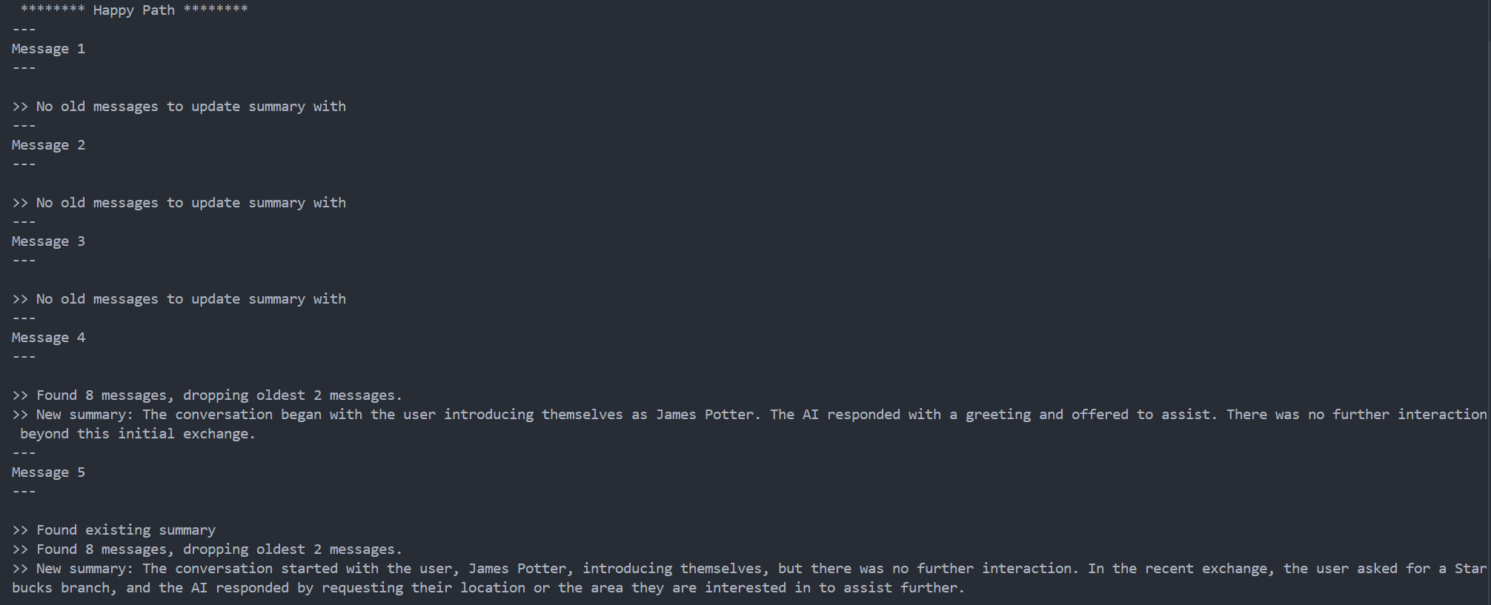
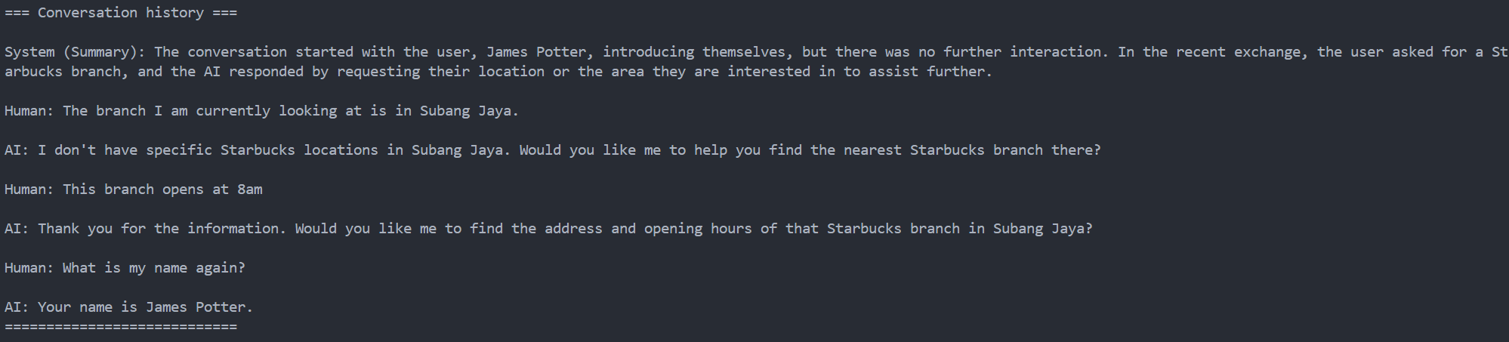
- Interrupted Path:
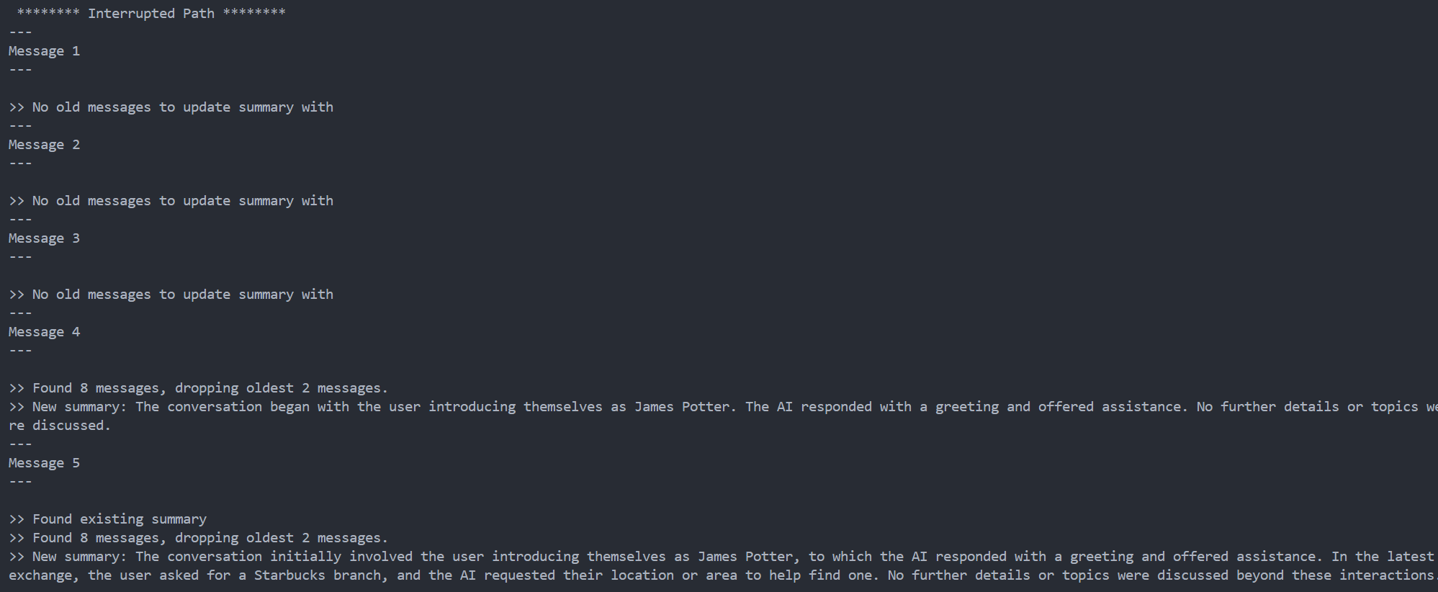
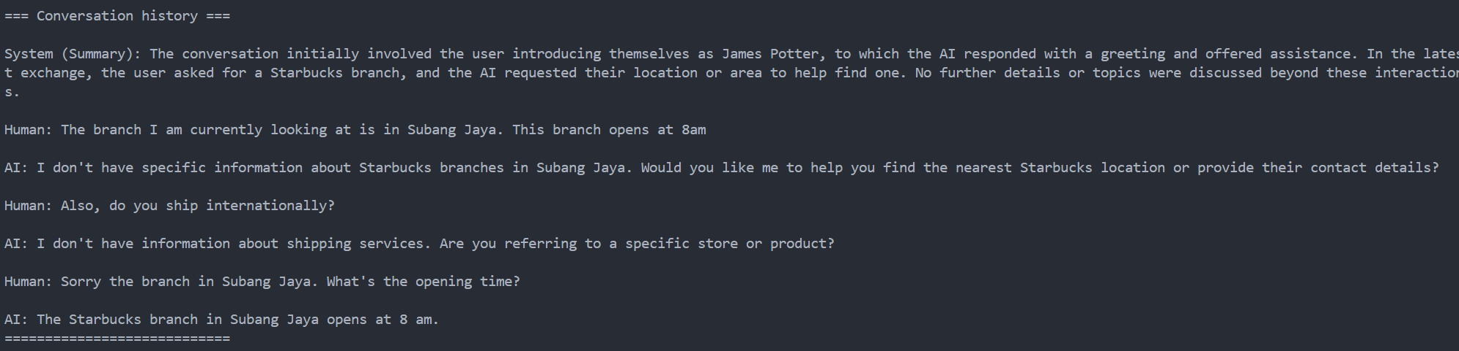

- I Don’t Know Path
